**Abstract: {…}**  **Introduction: {…}**

**II. Transducer Selection**  
A typical commercial piezoelectric transducer specification is depicted in **Table** 1. Based on the key parameters enlisted, the Simulink model of the active sonar system was designed. Long-range sonar generally uses an enclosed type transducer of which the outer peripheral is completely sealed. The selected piezoelectric transducer crystal is manufactured from PZT (Lead Zirconate Titanate) materials. There are several classes of PZT’s available **[8]**, each material having different physical characteristics and are subject to different applications. We chose PZT-4, as it has a high coupling factor and is also appropriate for a long acoustic range. Additionally, it is highly resistant to depolarization and the dielectric loss is minimum when driven by a high power drive. The resonant frequency of the selected transducer is $200 kHz$ having a bandwidth, $BW=8 kHz$. Piezoelectric transducer commonly uses $40 kHz$, $200 kHz, 500 kHz$ frequency crystal [**ref**]. High-frequency transducers are for ranging high-resolution underwater information. Despite, high-frequency transducer gives precise echo-ranging data, it is a trade-off with maximum distance coverage. Transmitted pulse for high-frequency shorter pulse tends to attenuate at a greater rate than low frequency wider pulse. The selected *BW* = 8 kHz is a narrow bandwidth which in contrast to wide bandwidth has fewer reverberations and shorter blanking distance. The beam angle of the selected transducer is 14.1°, which is considered a narrow beam. Narrow beam acoustic signal provides greater directivity but has less angular coverage. Transducer having higher $P_{rated}$ has a longer detection range and would eventually ensure stronger echo return. The rated power of the selected transducer is 50 W which is reasonable for a several hundred meters detection range. An input power closer to the rated value is designed in Sec. **III (b).**

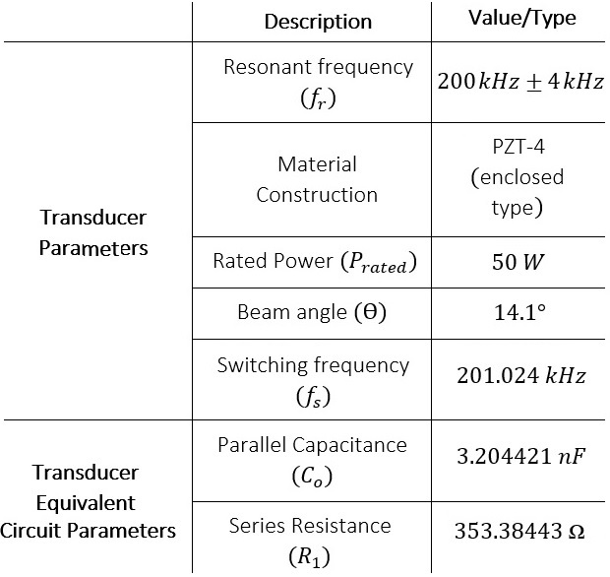

**Table. 1** Selected Transducer Specifications

**III. Transmitter Unit**

**{here: brief intro about the transmitter unit around a paragraph**

**- state the subsections name in this section**

**- a slight overview of the transmitter unit in less technical terms}**

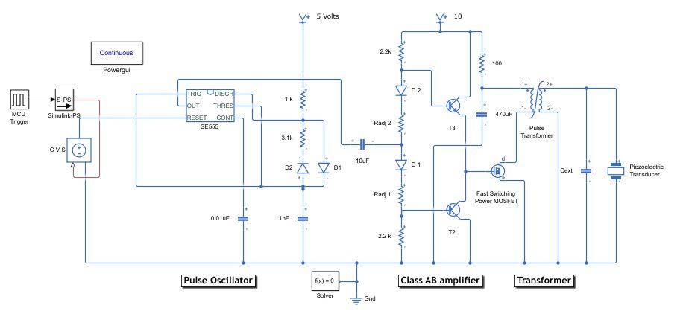

**Figure 1:** Transmitter (Tx) Unit Schematics

**III (a) Pulse Oscillator**

Pulse oscillator generates pulse wave at a frequency $f_{drive}$. Our goal is to set $f_{drive}$ equal to the resonance frequency $\left(f_{r}\right),$ to harvest optimum piezoelectric crystal vibration. Astable multivibrator using a class of 555 timers, SE555 IC was selected to generate pulse excitation signal. This pulse excitation is controlled by the MCU (microcontroller unit) which switches the timer SE555 on/off to allow/hinder pulse excitation. Simulink design of this module is realized into two separate units as shown in **Fig.1**.

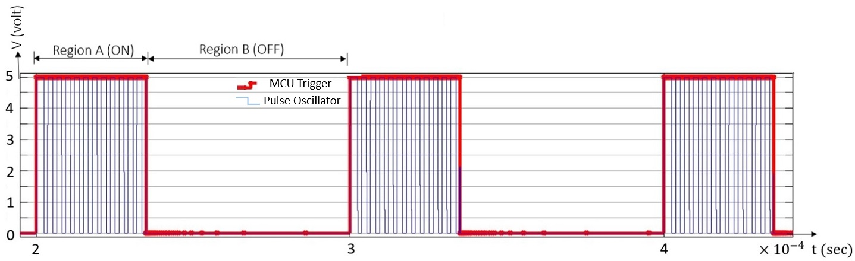The first unit is the ‘MCU Trigger’, which controls the number of cyclic pulses generated by the timer in each burst. From the virtual oscilloscope output in **Fig.2**, region A is the ON-period when MCU signals logic ‘1’. The width of this ON-period is directly proportional to the scope of information that can be held by return echo. During this period active bursts are generated continuously by the SE555 timer. The pulse width of this period can be adjusted to configure the number of cyclic pulses in each ON-period.

**Figure 2:** Pulse Oscillator output waveform

Let, $n$ be the number of cyclic pulses generated in each ON–period. Then the duration of each ON–period can be evaluated as follows: ${ T}_{H}=n× \frac{1}{f_{r}}$  
  
, where $T_{H}$ is the ON-period duration.  **(1)**   
  
It’s better to fix $n,$ and then calculate $T_{H}$. The standard value of $n$ is of order $8, 20, 40,$ and so on. From **eq.** 1, for $n=20,$ $T_{H}=100µsec$. This infers to generate 20 cyclic pulses at each ON-period the MCU must hold the logic level ‘1’ for around $100 µsec$.   
  
The second unit of the pulse oscillator circuit is the astable multivibrator SE555 timer, which continuously generates frequency at 200 kHz until $T_{H}$ goes down to logic ‘0’. The transducer is in active transmission or non-listening mode (**Fig. 1** region A), when $T_{H}$ is ‘high’. In practice, a piezoelectric transducer has an unfavorable characteristic, known as ringing. This brings about the extension of the transmission period by more than $T_{H}$. This gives the total duration, $T_{total}= T_{H}+ T_{ring}$, where $T_{ring}$ is the excess time due to ringing. If this duration can be minimized the pulse excitation efficiency can be improved significantly. In **Fig**. 1, region B is the listening (OFF- period), during this period transducer listens for echo and hence no transmission takes place. The transducer is completely isolated from the Tx unit, to prevent needless power loss and burst generation.   
  
From the second unit of pulse oscillator circuit following pre-design consideration is employed: $R_{B }> R_{A}$ 
  
, $C_{1 }=1nF$, ${ R}_{A}=1kΩ$, $C_{2 }=0.01µF$.  
  
The equations below were used to calculate the values of $R_{B}$ and the duty cycle D, $T_{H}=(ln2) \left(R_{A}+ R_{B}\right)C_{1}$ 
  
 **(2) ${ T}_{L}=\left(ln2\right)R_{B}C_{1}$** , **(3)**   
 where $T_{H}$ corresponds to logic ‘1’ and $T_{L}$ corresponds to logic ‘0’ of the cyclic pulse generated by the SE555 timer. To ensure the transducer operates at the resonant frequency we set the driving frequency $f_{drive}=200 kHz$. Then, we calculated the value of $R_{B}=3.1 kΩ$, after substituting the value of $R_{A}$ and $C_{1}$ in the $f_{drive}$ equation below $f_{drive}=\frac{1}{T}= \frac{1}{T_{H}+T_{L }}= \frac{1.44}{C_{1}(R_{A}+{2R}_{B})}$ 
 . **(4)**   
 The duty cycle *D* gives the percentage of the total duration $T_{H}$ is high, i.e., $D= \frac{T_{H}}{T_{H} + T_{L}}×100$, which can be evaluated as $D= \frac{R_{A}+ R_{B}}{R_{A}+ {2R}_{B}}$ $=$ $56.9\% .$ (**5)**

**III (b) Power Drive**

High voltage signal excitation is required to drive the transducer to maximize the mechanical vibration of the piezoelectric crystal which produces acoustic sound waves. Driven power must be close to the rated power of the transducer ($P_{rated}$ = 50W). In this stage, our focus is to design a circuit module that is capable to excite the transducer to yield maximum acoustic range and ensure significant echo return. Generally, two ways of excitations are available **[9]:**  
a) Transformer Drive (for enclosed type transducer),  
b) Power MOSFET Drive (for open type transducer).  
  
A high $P_{rated}$ enclosed type transducer requires the use of a transformer for excitation. Even though, $P_{rated}=50W$ might not appear to be significant in value, the purpose behind the use of the transformer is, it places itself as the best candidate to act both as a power drive and impedance matching circuit. In sonar system design, the transformer is widely used to step up voltage and its turns ratio is adjusted to match the impedance of the transducer. This ensures maximum power at the load, in this case, which is the transducer. In practical application, which involves sensing long acoustic range e.g., in ocean ranging, ultrasonic transducer might need to be excited at $P_{rated}$ in several ‘kW’. Therefore, an alternative to the transformer drive is roughly not there.

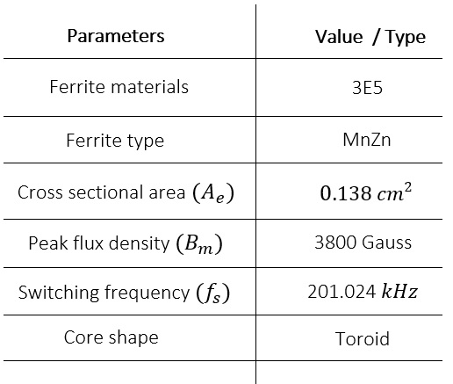  
The power drive stage is segmented into two distinctive parts, the Class AB amplifier unit, and the transformer unit. Pulse oscillator output voltage of ‘5V’ and low output current is incapable of the exciting primary side of the transformer. Therefore, a linear power amplifier (LPA) was used to trigger voltage and control $I_{p}$ (primary winding current) of the transformer. A Class AB amplifier, an LPA type amplifier was chosen for our circuit design. Compared to other LPA’s it has low cross-over distortion and is more efficient in terms of power amplification. From **Fig.1**, inclass AB unit the diodes D1 & D2 and transistors T2 & T3 are matching pairs. If these components are non-identical cross-over distortion could be reflected at the output of the Class AB amplifier (input to the primary winding of the transformer). A fast-switching power MOSFET, IRF640N as shown in **Fig. 1** was used to withstand a large current at the primary winding of the transformer.  
   
The transducer needs to be excited at 200 kHz frequency and 50W to maximize the electro-acoustic conversion. To achieve this, we need to consider both the rated power and frequency of the transducer, at the Tx unit. The signal output from the pulse oscillator is in pulse waveform at frequency 200 kHz and $56.9 \%$ duty cycle, when the transducer is in transmission mode. Based on the output generated by the pulse oscillator, we selected the Pulse transformer at the transformer unit. The specification of the selected transformer is depicted in **Table** 2.   
  
Pulse transformers are generally used in the application when the operating frequency is of higher order. High frequency (HF) transformers have few advantages in material construction **[10]**:  
  
a) as the frequency increases the transformer shrinks in size  
b) less Cu (Copper) wire is required which reduces Cu loss  
c) different geometric constructions are available **[11]**.  
  
Despite having upper hands over low-frequency transformers in some respect, HF transformer brings about a few drawbacks. The skin effect and proximity effect are the major challenges that need additional consideration in the practical design of a pulse transformer. Skin effect results due to high-frequency current streaming around the conductor.Litz wires are the common wire strands used to minimize this effect and reduce high-frequency Cu loss. This typical wire is twisted enabling current to distribute evenly, which is how the skin effect can be reduced. The proximity effect is eddy current losses, which are mainly due to magnetic fields induced by nearby conductors. Several practical design techniques described in **[10]**, can be followed to implement an efficient HF Pulse transformer.

**Table 2** Model Parameters of Pulse Transformer (Toroid)

From **Table** 2, ferrite types and materials are application-specific, mostly selected based on high permeability ($µ_{I=}10000$), minimum loss factor, and large $B_{m}$ value. An array of ferrite material grades and their specifications are listed in the component note **[12].**   
  
Transformer parameters used in our simulation model are evaluated from the equations below:

$L_{s}= \frac{1}{C_{o}×{(2πf_{s})}^{2}}$**(6) ${ P}_{rated}= \frac{{E_{s}}^{2}}{R_{1}}$**   
   
 **(7) ${ P}_{rated}= E_{s}× I_{s},$**   
  
  **(8)**

where $L_{s}$ is the inductance value of the secondary winding, $f_{s}$ is the switching frequency, $E_{s}$ and $I_{s}$ are the required voltage and current of the secondary winding, respectively.

Using the values of $C_{o}$& $R_{1}$ from **Table** 1, we obtain $L_{s}$ = 0.196mH. From **eq**.7 and **eq**.8, we obtain ${ E}_{s}=132.93V$ and $I_{s}=0.376A.$ Next, we evaluate the turns ratio and primary winding parameters: ${ N}_{p} = \frac{E_{p}× {10}^{8}}{kA_{e}B_{m}f_{s}}$ 
  
  
 **[10]** **(9) ${ N}_{s}=n× N_{p}$**   
  
 **(10) $n=\frac{E_{s}}{E_{p}}$**  **(11) $\frac{L_{S}}{L_{P}} = {\left(\frac{N_{S}}{N_{P}}\right)}^{2}$**    
 **(12) $\frac{I_{S}}{I_{P}} = \frac{1}{n}$**  . **(13)**   
 In **eq.** 9, $N_{p}$ is the number of turns of the primary winding, $E_{p}$ is the voltage at the primary side and $k$ is a constant. The value of $k$ depends on the wave shape generated by the transformer. For a symmetric pulse, the value of $k$ is considered as 4, which is the required value in our case [**ref**]. The notations $A_{e}{, B}_{m}$ and $f_{s}$ are defined in **Table** 2. From **eq.** (10-13), $N_{s}$ is the number of turns of the secondary winding and $n$ is the turns ratio of the transformer, $L_{p}$ is the inductance of the primary winding, and $I_{P}$ is the current at the primary winding.  
 Plugging in the values from **Table** 2 and after simple substitutions, the calculated values for our design are $N_{p}$ = 2 turns, $N_{s}=54 turns, n=27$ and $I_{p}=10.152A$. Note that in practice these values need to be re-adjusted based on the maximum voltage response across the terminal $V_{terminal}$ of the piezoelectric transducer. The process to get this response is termed impedance matching which is discussed in the next section.  
  
The design parameters of the Class AB amplifier can be readjusted to control the current $I_{p}$. The values of the current $I_{p}$ and $I_{s}$ might exceed the calculated value, due to unwanted transducer features such as ringing. To avoid this, an external capacitor $C_{ext}$ was connected to absorb excess charge. It is however better to remain at a slight capacitive region (phase angle shy of 0°) of impedance response as shown in **Fig. 4**.

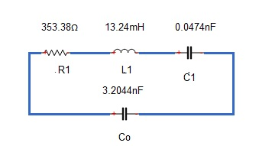 **III (c) Impedance Matching**  
Driving voltage $V_{drive}$ delivered by the power drive circuit to the piezoelectric transducer results in an electro-acoustic conversion from electrical energy to acoustic energy. The mechanical vibration of the piezoelectric crystal is in correspondence to the applied $f_{drive}$. Mechanical response reaches an optimum level when the natural frequency of the piezoelectric material matches with the driving frequency ${ f}_{drive}$. The frequency of the piezoelectric crystal at which the response occurs is termed the resonance frequency ${ f}_{r}$. The transducer has a specific resonant frequency which is a function of the material composition and mechanical dimension. The objective of the impedance matching unit is to drive the transducer to work at ${ f}_{r}$, to extract maximum mechanical vibration of the piezoelectric crystal (hence maximum efficiency in electro-acoustic conversion). Naturally, transducers are capacitive and have high input impedance compared to the output impedance of the power drive circuit i.e., $Z_{out}\left(Power drive \right){≪Z}_{in }(Piezoelectric crystal)$. Due to the impedance mismatch, huge energy is wasted if excited in such conditions, which results in low transmission efficiency. To attain efficient transmission the capacitive effect of the transducer must be resonated out. This is achieved by exciting transducer to vibrate at ${ f}_{r}$.   
   
Several impedance matching techniques are available, of which two common ways are explained below:  
  
a) The simplest method is to add external inductors by trial-and-error methods **[13]** until the overall impedance of the transducer is purely resistive. It might facilitate simplicity but requires several iterations which is unfeasible in the practical case. Moreover, for high-powered transducers e.g., Piezoelectric Tonpilz this technique is inconvenient.   
  
b) More rational and systematized approach is to use a transformer for both power drive and impedance matching units. In our case, we used this technique to create a simulation of the power drive as well as to impedance match transducer. Turns ratio of the secondary coil, $N_{s}$ of the transformer can be adjusted to make the transducer purely resistive. This process resonates out the capacitance of the transducer and compensates for the imaginary component of the impedance (not the real part). A proposed methodology has been analyzed in the paper **[14],** where both the imaginary and real part was matched. We restrict our analysis to resonate imaginary components and use the approximation method by adjusting ${ N}_{s }$ until maximum power can be obtained.   
  
The piezoelectric transducer can be modeled as a mechanical and electrical portion according to BVD (Butterworth-Van-Dyke model). This model was used to formulate the expression for the input impedance of the transducer as seen by the transformer. BVD model parameters have been inserted in **Fig. 3**, for the selected transducer. The branch parameters R1, L1, and C1 depict the mechanical portion and Co the electrical portion, following the BVD model [**ref**]. The branch parameters have been inserted following the datasheet of the transducer [**ref**]. The overall impedance *Z(s)* of this model is capacitive for the parameters as shown in **Fig**.3. The simplified general equation of the input impedance *Z(s)* is given by **eq**. 14.

**Figure 3:** BVD model of Piezoelectric Transducer

$Z\left(s\right)=\frac{s^{2}L_{1}C_{1}+ sR_{1}C_{1}+1}{s^{3}L_{1}C_{1}C_{o}+{ s}^{2}R_{1}C_{1}C_{o}+sC_{o}+ sC_{1}}$**(14)**

After plugging the value of the parameters in **eq**. (14), Z(s) can be evaluated as, $Z\left(s\right)=\frac{{(6.27×{10}^{-13})s}^{2}+ (1.67×{10}^{-8})s+1}{{(2.01×{10}^{-21})s}^{3}+{ (5.36×{10}^{-17})s}^{2}+(3.25×{10}^{-9})s}$ 
  
 **. (15)**

Next, we evaluate the resonant frequency $(fr)$ and anti-resonant frequency $(fa)$, using the equations below: $fr$ = $\frac{1}{2π√L_{1}C_{1}}= 201.02 kHz$**(16)**

$fa$ = $\frac{1}{2π√\frac{{ L}_{1}CoC_{1}}{C_{1}+C_{o}}}= 202.50 kHz.$**(17)**

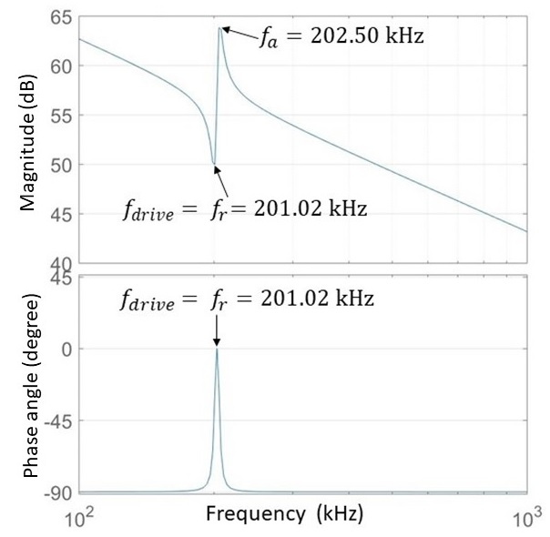

**Figure 4:** Impedance matching response (after impedance matching)

From the impedance magnitude response graph **Fig.4**, the frequency at the trough is the resonant frequency ${ 'f}_{r}'$ and the frequency at the peak is the anti-resonant frequency ${ 'f}_{a}'$. The electro-acoustic gain ratio is maximum near ${ f}_{r}$ and the electro-acoustic power is maximum near ${ 'f}_{a}'$ [**ref**]. From the power drive stage, the maximum voltage response $V_{terminal}$ can be observed at the frequency ${ 'f}_{r}'$. Phase plot of impedance response depicts the characteristic nature of a piezoelectric transducer. A piezoelectric transducer acts like a capacitor without any external load. Therefore, before $f_{drive}$ is applied, the current **I** leads the voltage **V,** and the phase angle resides in the capacitive region. After $f_{drive}$ is applied and $f_{drive}$ approaches $fr$, the phase angle reaches ‘0’ degree, i.e., when **I** is in phase with **V**. The phase angle ‘0’ degree, confirms that the excess capacitive effect of the transducer has been nullified with the addition of inductive effect at ${ f}_{r}$.